**SRM INSTITUTE OF SCIENCE AND TECHNOLOGY**

**DEPARTMENT OF COMPUTER SCIENCE AND ENGINEERING**

**KATTANKULATHUR – 603 203**

**15IT304J- Web Programming Register Number: RA1711003011471**

**Name:Manvi Singh Chandel**

**Experiment No: 10**

**Date: 26/10/2020**

**Aim:** **Application for web services**

**Conversion of Fahrenheit to Celsius and vice versa**

**Input:**

**(VBScript File)**

<%@ WebService Language="VBScript" Class="TempConvert" %>  
  
Imports System  
Imports System.Web.Services  
  
Public Class TempConvert :Inherits WebService  
  
<WebMethod()> Public Function FahrenheitToCelsius(ByVal Fahrenheit As String) As String  
  dim fahr  
  fahr=trim(replace(Fahrenheit,",","."))  
  if fahr="" or IsNumeric(fahr)=false then return "Error"  
  return ((((fahr) - 32) / 9) * 5)  
end function  
  
<WebMethod()> Public Function CelsiusToFahrenheit(ByVal Celsius As String) As String  
  dim cel  
  cel=trim(replace(Celsius,",","."))  
  if cel="" or IsNumeric(cel)=false then return "Error"  
  return ((((cel) * 9) / 5) + 32)  
end function  
  
end class

**(HTML FILE)**

<html> <head> </head>

<body>

<form action='tempconvert.asmx/FahrenheitToCelsius'  
method="post" target="_blank">  
<table>  
  <tr>  
    <td>Fahrenheit to Celsius:</td>  
    <td>  
    <input class="frmInput" type="text" size="30" name="Fahrenheit">  
    </td>  
  </tr>  
  <tr>  
    <td></td>  
    <td align="right">  
     <input type="submit" value="Submit" class="button">  
     </td>  
  </tr>  
</table>  
</form>  
  
<form action='tempconvert.asmx/CelsiusToFahrenheit'  
method="post" target="_blank">  
<table>  
  <tr>  
    <td>Celsius to Fahrenheit:</td>  
    <td>  
    <input class="frmInput" type="text" size="30" name="Celsius">  
    </td>  
  </tr>  
  <tr>  
    <td></td>  
    <td align="right">  
    <input type="submit" value="Submit" class="button">  
    </td>  
  </tr>  
</table>  
</form>

</body> </html>

**Output:**

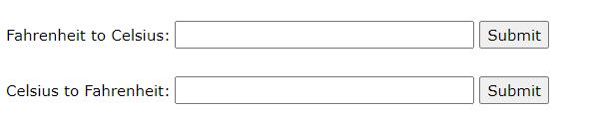

**Result: An application for web services was developed successfully.**